j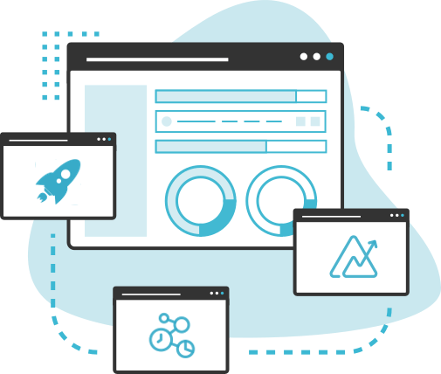

Zoho Implementation Proposal For

13 Apr 2024
Created By:
Priyam Modi
+91 8591044966
priyam@fristinetech.com

About

Fristine Infotech
Fristine Infotech is India's leading Premium Zoho Partner helping clients across markets, industries & geographies solve complex business problems through bespoke consultation, implementation, and adoption of various Zoho Applications.

We have been a strategic partner for Zoho for the last 7 years and have successfully completed over 200+ implementations across Marketing, Sales, Operations, Finance, and Support Functions.

For More Information Please Visit: Fristine Infotech Website

Our Recent Awards:


Our Clients
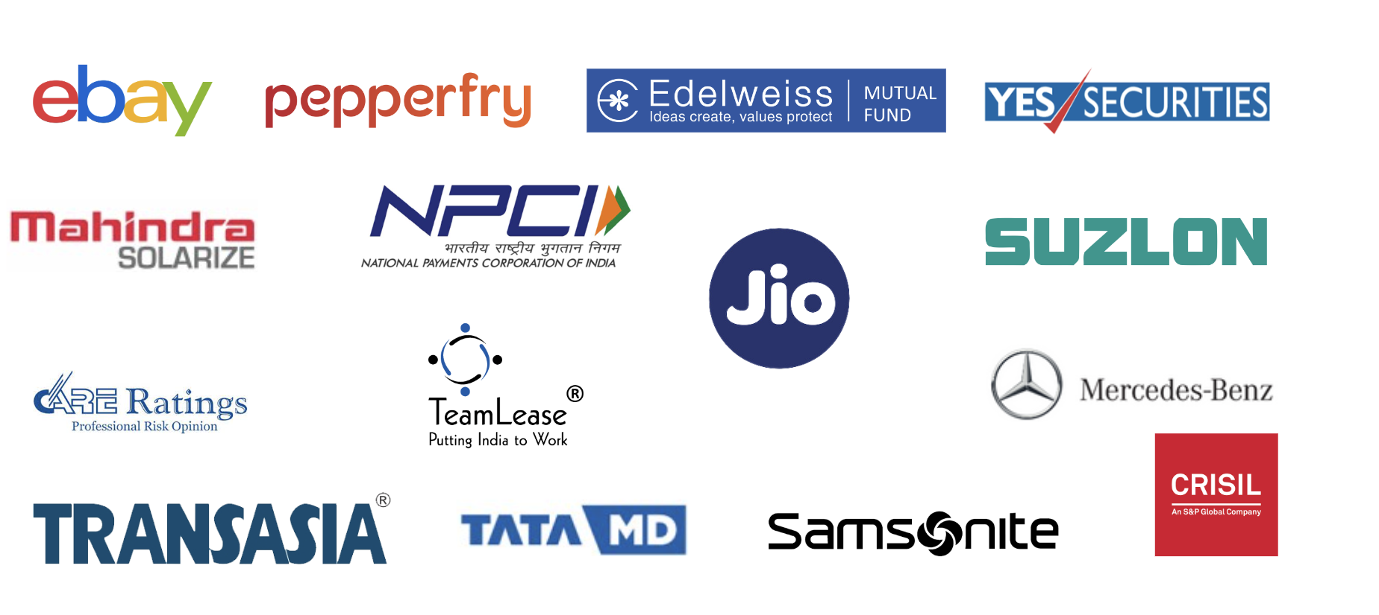

Proposal
Reliance Hospitals currently using On Premise SAP software to manage their business & now want to shift to the Zoho Platform & implement their entire business processes like sales & marketing to provide a better and more engaging experience to the existing & new customers They have identified Zoho CRM Plus as one of the platforms to digitize and optimize these processes.

Scope of work
- Zoho CRM
1. Standard Configuration
1.1 Company Creation
1.2 Hierarchy Configuration
1.3 Currency Configuration
1.4 Timezone Configuration
1.5 Holiday List
1.6 Calender Setting-up
1.7 Email Authentication
2. User Configuration
2.1 Roles Creation
2.2 Profiles Creation
2.3 Profiles Permission
2.4 User Creation
2.5 Territory Creation

3. Module Customization
3.1 Lead Module Customization
3.2 Contact Module Customization
3.3 Accounts Module Customization
3.4 Opportunity Module Customization & Pipeline Customization
3.5 Activities Module Customization
3.6 Partners (Accounts & Contacts)
3.6 Additional Custom Modules (up to 5 Modules)
3.7 Customer 360 Degree
4. Workflow Automation
4.1 Lead Generation Via Automation
4.2 Lead Conversion via Automation
4.3 Other Workflow Automation (Up to 7)
4.4 Lead Assignment.

5. Reports & Dashboards
5.1 Standard Home Page Customization
5.2 Standard Reports Customization
5.3 Standard Dashboard Customization
5.4 Custom Reports & Dashboard (up to 10)

- Zoho SalesiQ
1.1 Sales IQ Standard configuration
1.2 Company set up
1.3 User Set up
1.4 2 Targeting and routing rules set up
1.5 1 Chatbot setup - Up to 20 decision trees
1.6 Standard reports set up
1.7 Visitor tracking setup
1.8 Integration with Zoho CRM & Campaigns

- Zoho Campaigns
1.1 Standard User configuration
1.2 List Templates (up to 5)
1.3 Email Templates (Upto 5)
1.4 Workflow Creation (up to 5)
1.5 Campaigns Wise Standard Reports
1.6 2 Nurturing Journeys
1.7 1 A/B Testing Campaign
- Zoho Social
1.1 Social set-up for (upto 1 brand)
1.2 Facebook, Instagram, & Google Ads
1.3 Integration with Zoho CRM & Campaigns

- Integration

1.1 What's app (Haptik)
1.2 Telephony Integration with Zoho CRM
1.3 Landing Page Integration (Up to 2 Pages)
1.4 Web to Lead Integration (Up to 2 Forms)
1.6 On Premise SAP Integration with Zoho CRM
1.7 Hospital Information System Integration with Zoho CRM

- Provide following Go Live Support:
1.1 User Training
1.2 Custom user guide.
1.3 30 Days Hyper- care

Assumptions:

Project Team
Sr .no | Role | Role Description
1. | PCTO | ‌Accountable for Architecture Plan and Risk mitigation.
2. | Project Manager | Accountable for overall project outcomes.  Day to day control and management of progress & Status.
3. | Sr Business Analyst | ‌Accountable for overall Business/functional requirements and  User Training.  Responsible for creating Business Process/Product Backlog.
4. | Junior Business Analyst | ‌ Accountable in Helping in documentation of Business/Functional requirements.
5. | Sr Developer | Accountable for Quality Development.  Responsible for Completion of development/Implementation  task.
6. | QA/Software Test | ‌Accountable for QA/Testing of the application.  Responsible for Test planning and execution.
Project Governance & Checkpoints
Sr .no | Type of Governance and Checkpoint
1. | ‌Requirement Gathering from all business stakeholders for  CRM and Desk
2. | ‌Functional Solution Document (FSD) Review
3. | ‌FSD Sign-off
4. | ‌Doubt clarification during development phase
5. | ‌User walkthrough session
6. | ‌User Acceptance Testing Round
7. | ‌Ticket submission on identified issues
8. | ‌User training
9. | CRM & Sales IQ user training
10. | Social & Campaign user training
11. | ‌Leadership sign-off

Commercials:
Software Implementation:
Sr. No. | Particulars | Commercial  Type | Estimated Hours | Hourly Rate | Total Amount (INR)
1 | Zoho CRM, | Project-based | NA | NA
2 |  | Time & Material
3 | 30 days Hyper-care on delivered item (no new change request) | Included in Project | - | -
Total without Retainer Exclusive of GST]
4 | Post-Hypercare  (Managed Services) (12 Months) | Time & Material
Total without Retainer [Exclusive of GST]

Note:

Above pricing exclusive of GST

Zoho License cost is not included in this proposal.
- Third-party software License cost not included in this proposal (Reliance Hospitals team need to purchase from third-party service provider)
- Retainer plan post hyper care for enhancement/maintenance.
- Training includes User training only, we do not provide admin training.
- If travel, food, and lodging are required, it will be charged separately after written approval from the client.

Payment Terms
- Zoho License cost need to be paid full upfront to Zoho in advance
- 60% Implementation Cost Payable in advance
- 40% Implementation Cost Payable on Go Live
- For Time & Material consumption, actual hours consumption will be tracked via Zoho Projects.
- Retainer services will be billed quarterly in advance.

Timeline:
- Post we received PO from the Reliance Hospitals project and will get started within 15 days.
- Entire project will take 12 Weeks + 2 Weeks Buffer

Constraints
- Actual delivery date may change on the basis of the timely response of various stakeholders.
- All third-party Integration will depend on the technical capabilities & API support of those platforms.
- Implementation will depend on the Zoho platform's current capability & limitations.

Next Steps
Steps | Agenda | (FI Team) | (Reliance Team)
Service Level Agreement | This will define all the  Terms and conditions from both parties | Sales Representative | Champ
Software License (If Required) | Over here procurement  Of license would be done | Sales Representative or Zoho Team | Champ
Vendor Registration  (If Required) | If any vendor registration required to be done for onboarding | Sales Representative | Champ
Purchase order | Reliance need to raise  PO for Service Fee and License Fee to Zoho separately | Not Applicable | Finance Team
Invoicing | The Reliance team needs to process invoicing to Zoho and Fristine separately | Accounting Manager | Finance Team

